43.78: The activity of the original iron, after 1000 hours of operation, would be .
The activity of the oil is 84 Bq, or 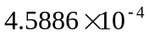 of the total iron activity, and this must be the fraction of the mass worn, or mass of 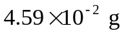. The rate at which the piston rings lost their mass is then 

